July 1, 2014

Greetings, APDs!

America’s mass incarceration epidemic has been garnering a lot of attention recently, even by people outside of our PD circles. The National Academy of Sciences (NAS) recently released [a report](http://www.nap.edu/download.php?record_id=18613) on mass incarceration available for free download, which has in turn prompted a wave of news coverage. The [News & Updates](http://ncids.com/pd-core/?page_id=2) section of our website is a great way to quickly browse some of the recent coverage.

There is no way to talk about mass incarceration without talking about racial inequality. [The statistics](http://www.aclu-md.org/our_work/tackling_mass_incarceration_in_maryland) are shocking and terrifying. One in three black males born today can expect to go to prison. African American males constitute nearly 1 million of the 2.3 million people incarcerated. The NAS report covers some of the reasons for this disparity beginning at page 91. Of course another excellent resource for understanding the disparities is [Michelle Alexander’s *The New Jim Crow*](http://www.amazon.com/The-New-Crow-Incarceration-Colorblindness/dp/1595586431/ref=sr_1_1?ie=UTF8&qid=1404095680&sr=8-1&keywords=the+new+jim+crow).

The history and statistics are depressing, but **read on for some motivation!** There is one new study that should give us hope. A group of researchers have found that incarceration moves through society like infectious disease – in short, *prison is contagious*.

The study uses a statistical model to show that small differences in sentences can and do lead to drastic differences in incarceration rates over time. There is a tipping point at which incarceration spreads like an infectious disease. Researchers used the average drug sentence – 14 months for whites and 17 months for blacks – to track the subsequent result of incarceration over time in a community. The chart below demonstrates what they found. To learn more, check out [this article](http://news.sciencemag.org/biology/2014/06/prison-contagious) for a summary, [this one](http://www.smithsonianmag.com/smart-news/longer-prison-sentences-make-incarceration-more-contagious-180951884/?no-ist) for a discussion of the methodology, or the [published study itself](http://rsif.royalsocietypublishing.org/content/11/98/20140409).

This research suggests that the work you do to save months, weeks, or even mere days of prison time has an impact well beyond your individual client. The success you have in reducing and eliminating racial inequity in sentencing on a case by case basis matters. Mass incarceration has wrecked devastating consequences, and you are out there chasing the cure!

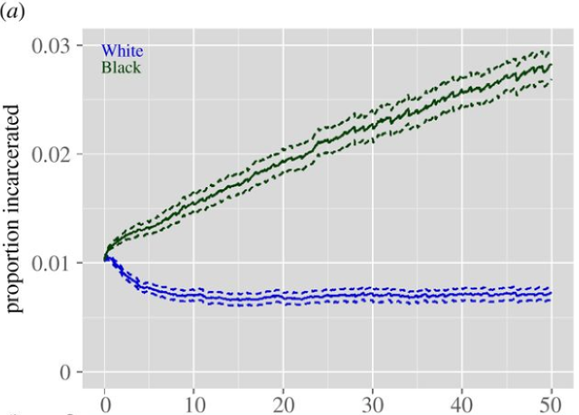

We would love for you to join our organization! You will find the link to do so on the bottom right portion of the [webpage](http://ncids.com/pd-core/). If you have feedback about *Race Judicata*, we’d love to hear from you. Please respond to the original poster only, rather than the APD listserv.